**Design Document for Project: BiteNow**

**Green Team**

**Team Members:** Emmanuel Akinseye, Ann Chen, Ryan Engelken, Maurice Farr, and Harjot Singh

Department of IT, Ivy Tech Community College

Dr. Carver

SDEV-265

April 7, 2025

**Tables of Contents**

**Introduction****3**

**Entity Relationship Diagram 4**

**Sequence Diagrams 5-6**

**Architecture Design Diagram 7**

**Class Diagram 8**

**Database Design 9**

**Interface Design 10-11**

**Use Cases 12-13**

**Test Cases 14**

**Summary 15**

# 

# 

# 

**Introduction**

The purpose of this design document is to provide a framework for developing a food delivery service website targeted at universities and colleges in Indianapolis. This application will replicate the functionalities of a service like DoorDash, allowing students and faculty members to order food from a variety of local restaurants and have it delivered to their campuses or dormitories. The document details the system's architecture, entity relationships, class diagrams, interface designs, use cases, test cases, and comprehensive database design, ensuring all elements work together for a smooth and efficient user experience.

Regarding hardware requirements, the project will utilize personal computers, including desktops and laptops, to facilitate the completion of assignments and project-related tasks.

In terms of software requirements, Visual Studio Code will serve as the primary integrated development environment for Python programming. The frontend will be developed using HTML, CSS, and JavaScript, while the backend will be built on a robust framework such as Django. SQLite will be employed for database management to store user information, restaurant menus, and order histories. Furthermore, APIs will be integrated to incorporate third-party services, including mapping functionalities for location tracking.

**Entity Relationship Diagram (ERD)**

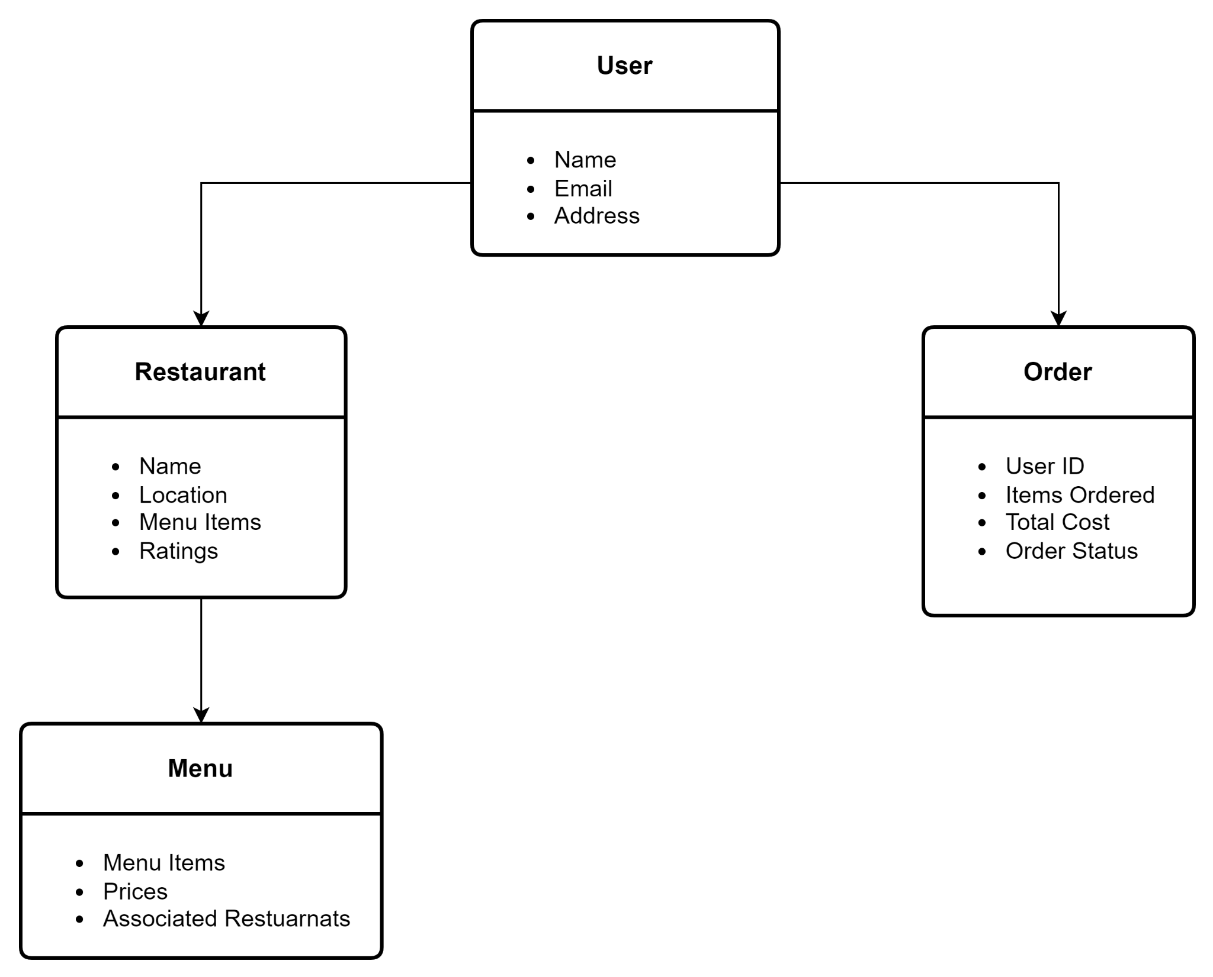

**Sequence Diagrams**

* **Placing an Order Diagram:**

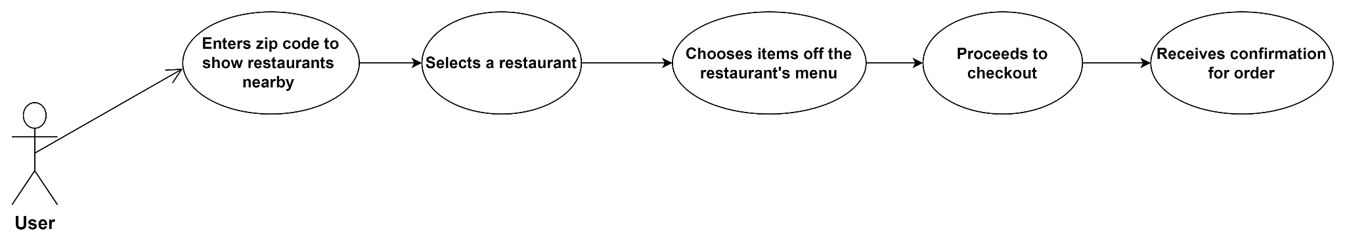

* **Restaurant Confirmation Diagram:**

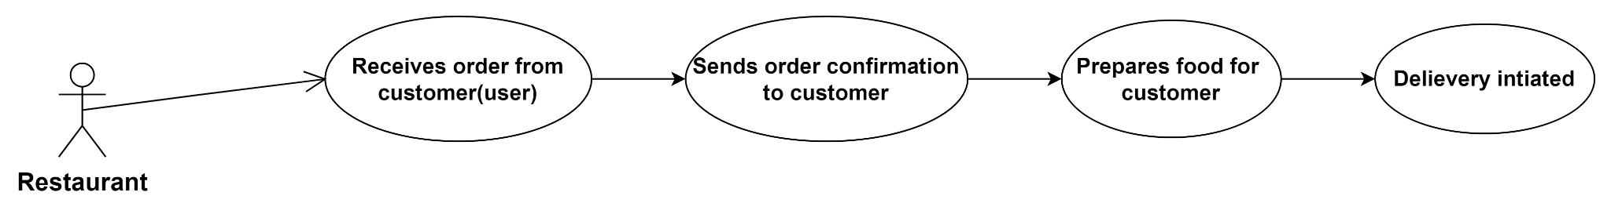

* **User Account Creation/Logging In:**

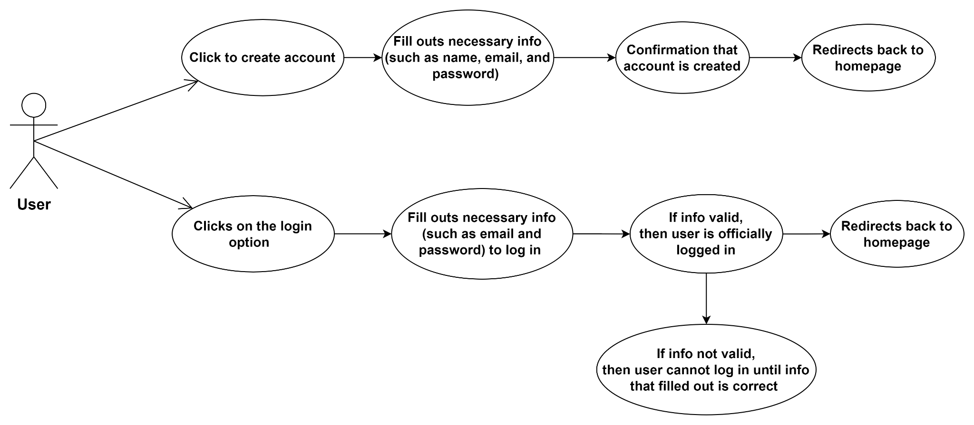

**Architecture Design Diagram**

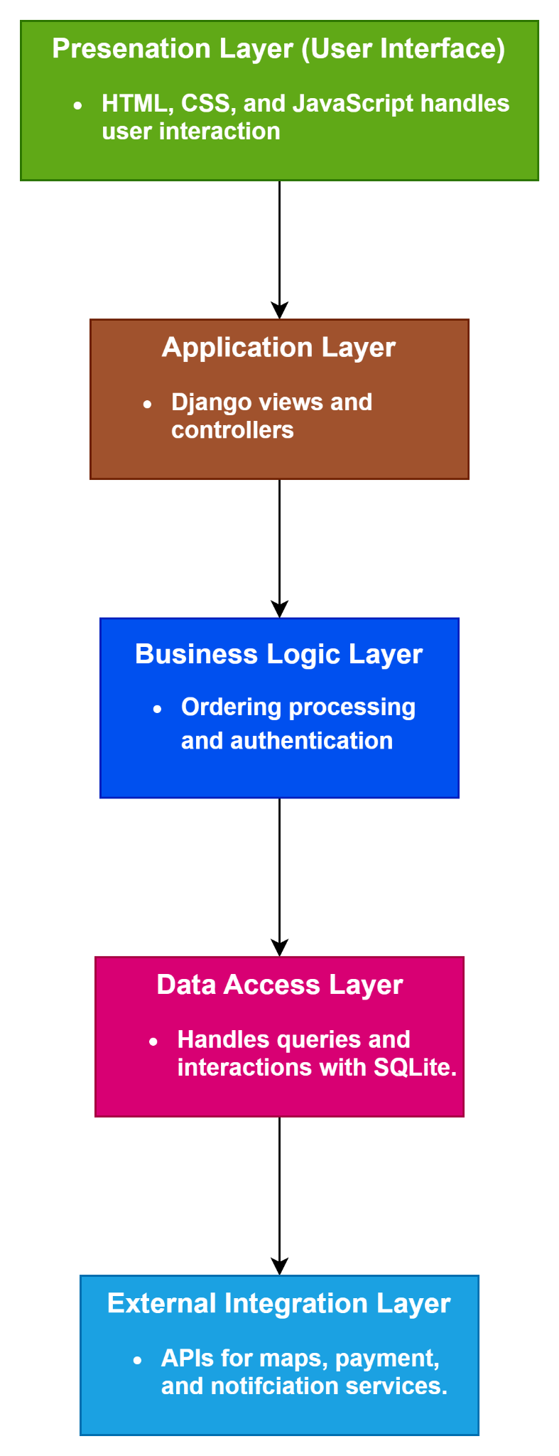

**Class Diagram**

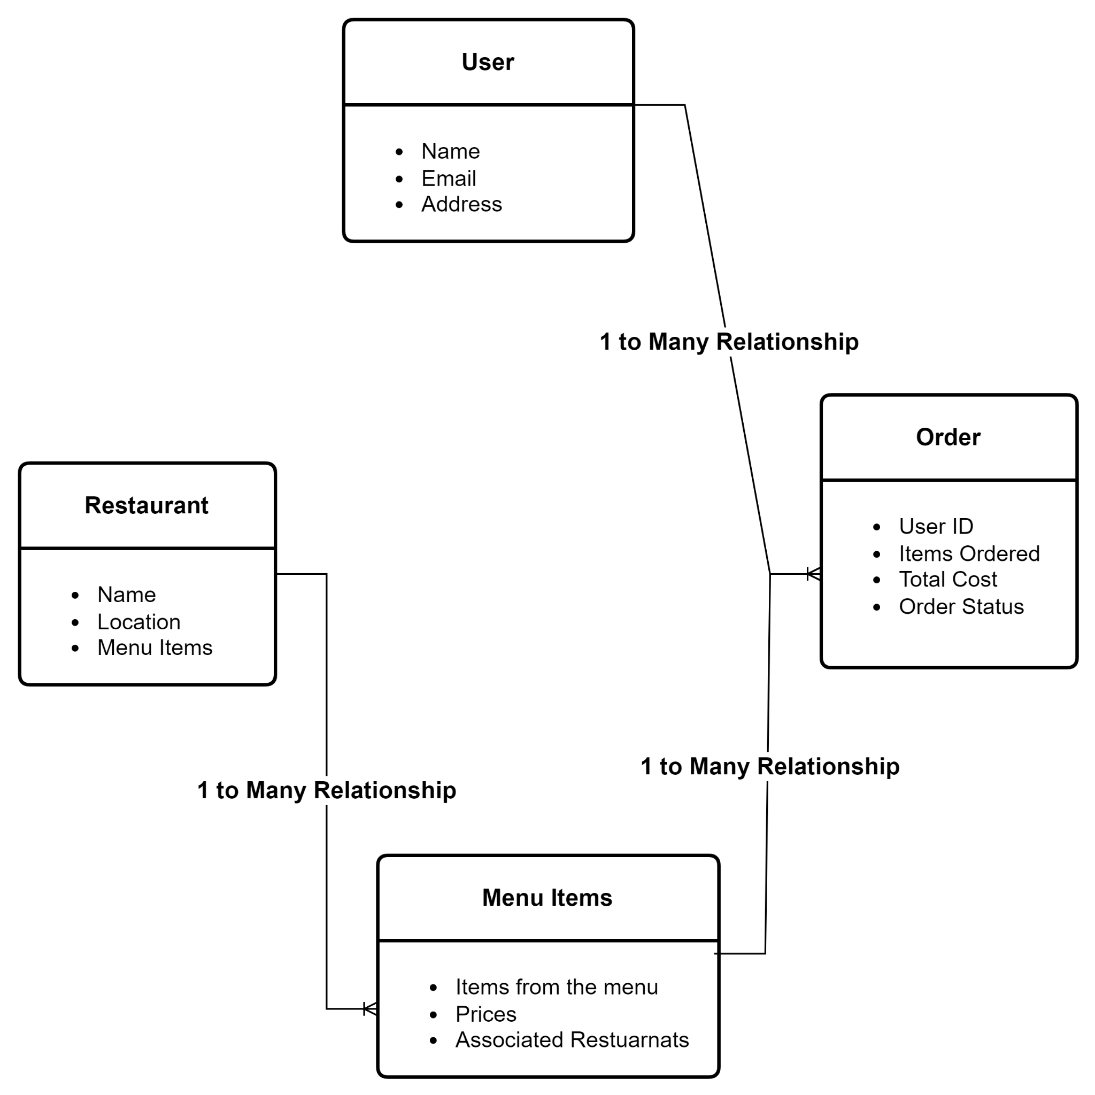

**Relationships Description:**

* A user is capable of placing multiple orders, which defines a one-to-many relationship.
* A restaurant offers numerous items on its menu, illustrating a one-to-many relationship.
* An order can consist of several menu items, representing a one-to-many relationship.

**Database Design**

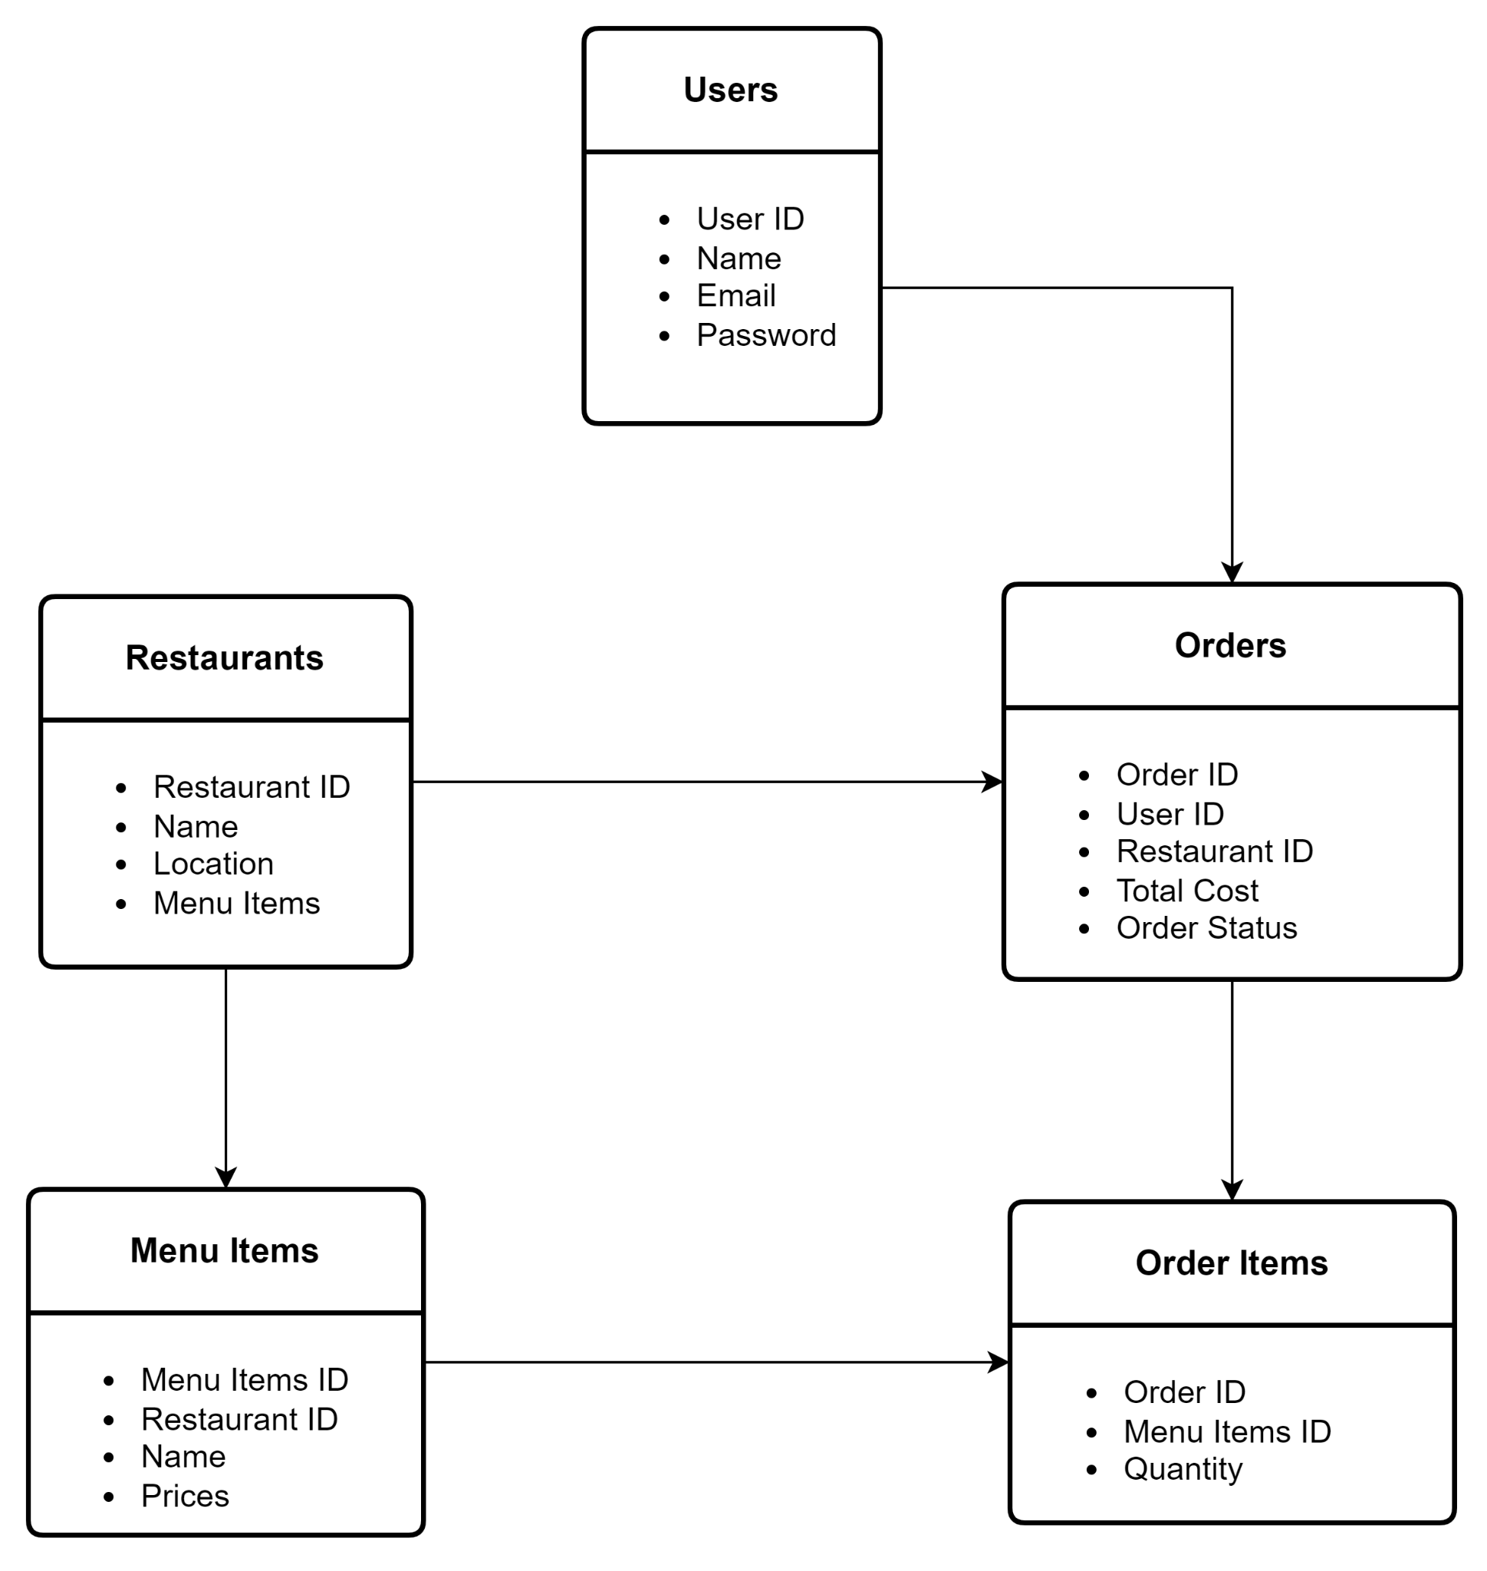

**Interface Design**

**Front End:**

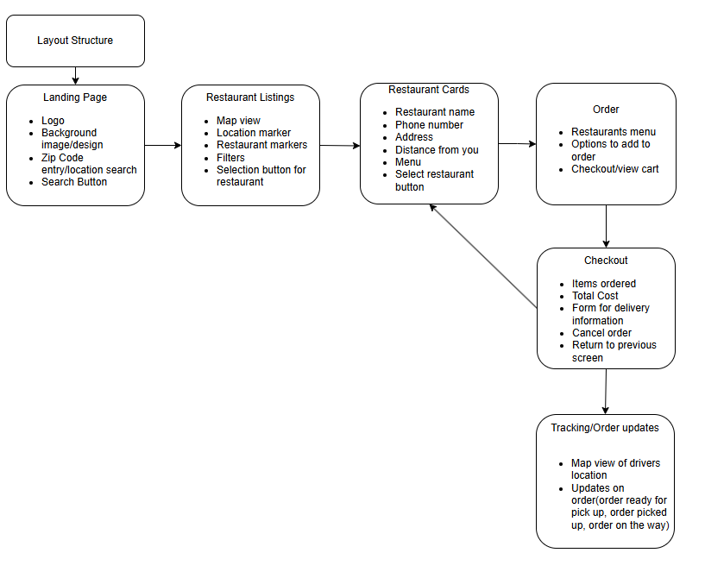

**Backend:**

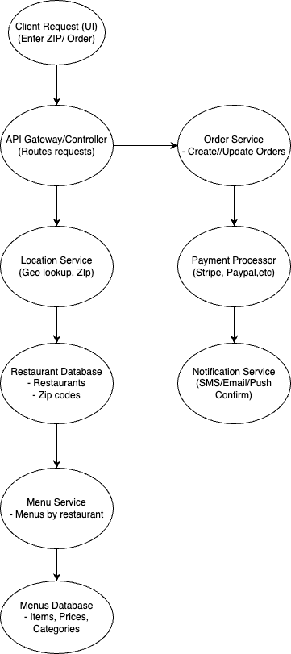

**Use Cases**

* **Account Creation and Login:**

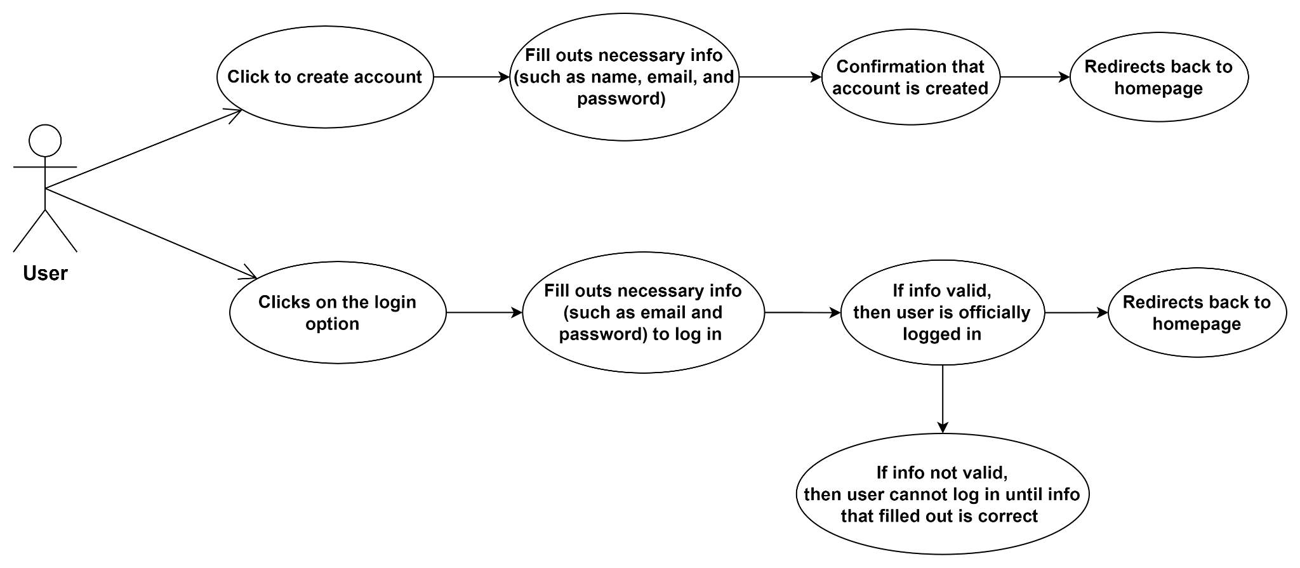

* **Restaurant Listings and Search:**

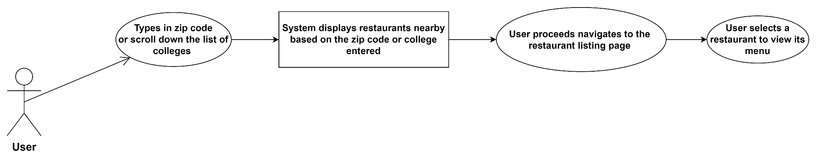

* **Menu Browsing and Order Placement:**

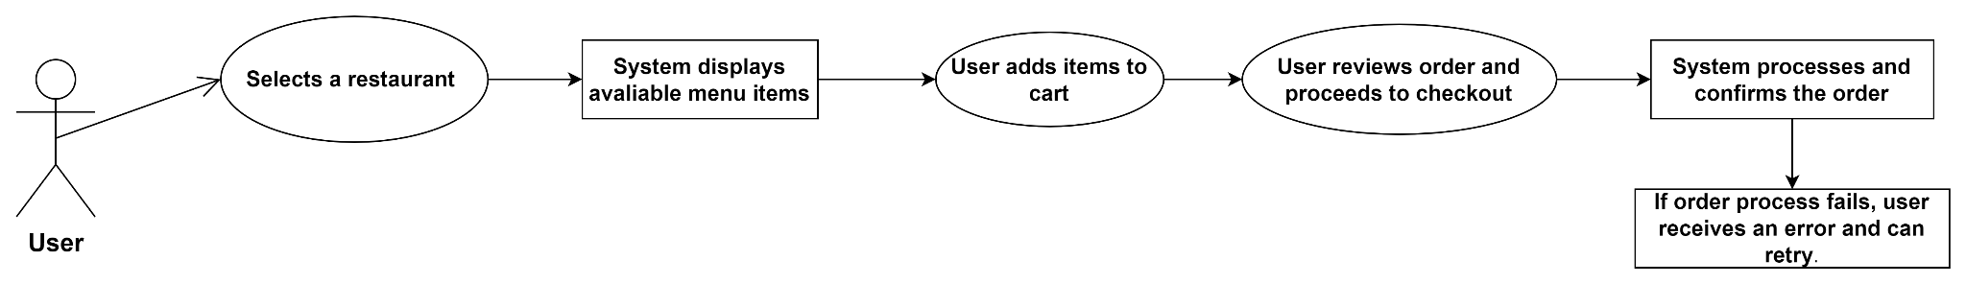

* **Order Tracking:**

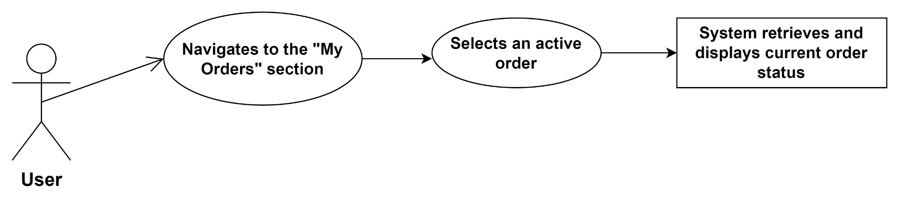

**Test Cases**

|  |  |  |  |
| --- | --- | --- | --- |
| **Test Case ID** | **Description** | **Input** | **Expected Output** |
| TC001 | Register new user | Valid user data | Account is created |
| TC002 | Login existing user | Correct email & password | Redirect to homepage |
| TC003 | Place order | Menu items + checkout | Order confirmation screen |
| TC004 | View order history | Logged in user | List of past orders |
| TC005 | Update menu (admin) | Updated menu info | Menu is saved successfully |

**Summary**

This design document presents the framework, architecture, and workflow of the food delivery service application tailored for universities and colleges in Indianapolis. It provides descriptive details about the database, user interfaces, use cases, and test cases, ensuring the application fulfills all necessary functions and performance criteria. This document will assist the development team in executing the project and will also serve as a basis for future enhancements and maintenance.